Approaches to Controlling Influenza

* **Avian: - How does migration effect competition with-in patch dynamics?**

Avian influenza is a deathly virus that kills many birds every year. A two-patch avian influenza model with migration between patches is created to address the question at hand. An elasticity analysis with respect to certain compartments and parameters are performed to determine which parameters we can apply control measures.

* **Humans: Can School-Located Influenza Vaccination Programs Protect the Community from Influenza?**

Influenza is an important vaccine-preventable public health burden. School-located influenza vaccination (SLIV) programs could substantially enhance the sub-optimal coverage levels achieved under existing delivery strategies. Three decades of epidemiologic and computer modeling studies support the concept that immunizing children can indirectly protect unimmunized adults in the same community. Transmission studies suggest that schools are virus exchange systems, and children shed greater quantities of virus and for longer periods of time than adults

Take home messages:

1. Bird movement between farms can be important.

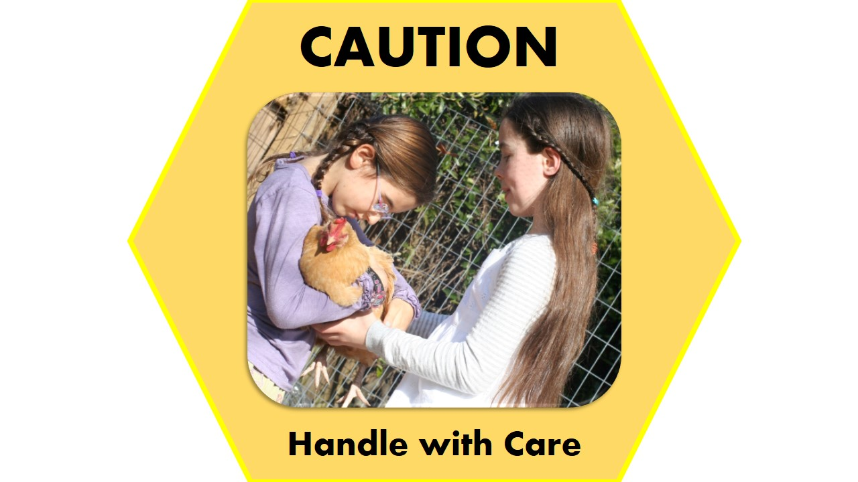

1. Get your influenza vaccine!